**Distributed Cryptocurrency Trading System**

1. Objective: Java RMI API to implement distributed applications. In this project, you will be utilizing distributed Java RMI registry and implementing client- server interaction using Remote Objects and Remote Interfaces.
2. Project Specification: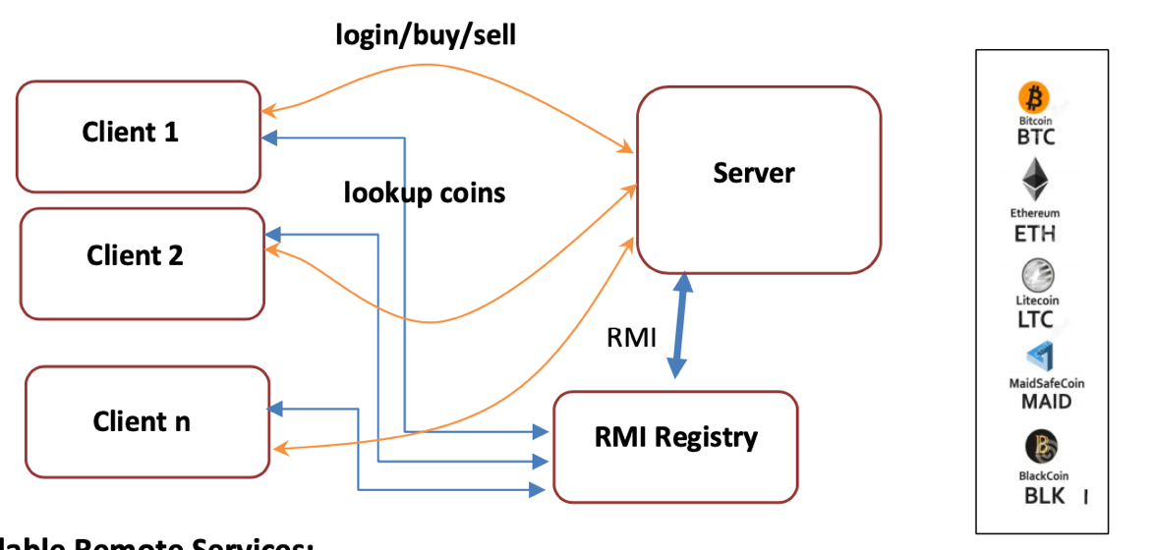

**Flow Chart:**

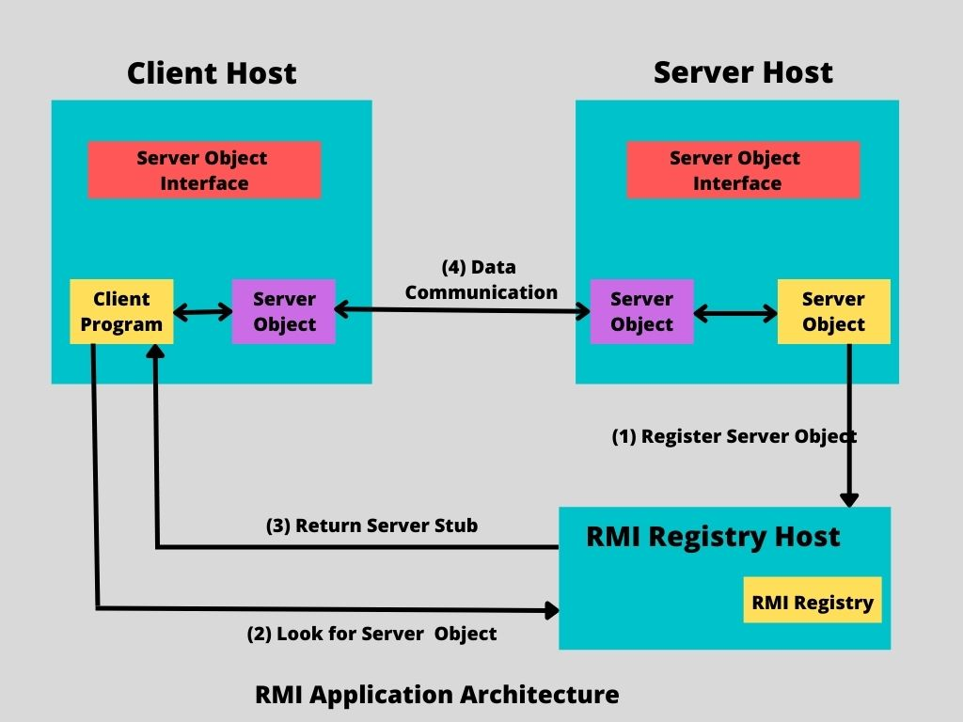  
  
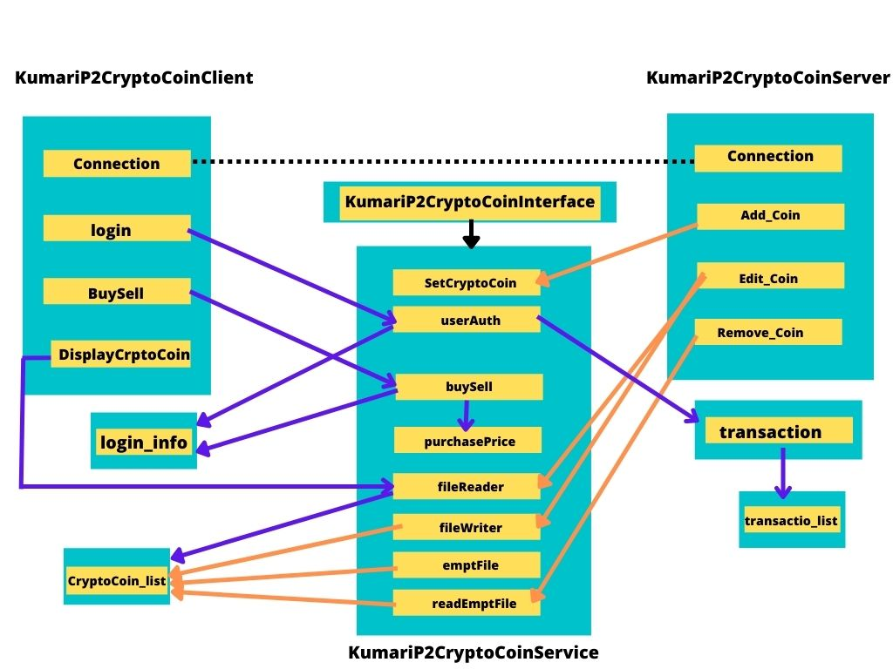

Files Flow Chart

Features:

* 1. New Crypto coin identified by a name, abbreviated name, description, market cap, trading volume, opening price and timestamp.
  2. Crypto Coin servant class to generate coins with unique name (use abbreviated name) and initial values.
  3. Crypto Coin new coins, remove coins, and edit coins use bind, rebind, remove, and other operations to complete its intended work.
  4. The trading system is ready with coins, a client needs to login with matching credentials to operate in the trading system. Server is responsible to provide the login service
  5. After successful login, server identifies and regenerates client’s state (deserialize) which includes client name, id, purchase power (amount), all crypto coins the client has purchased along with purchase price, quantity, and timestamps.
  6. Client is now allowed to buy or sell coins from the market. After each transaction, clients purchase power, coin details needs to be updated accordingly.
  7. As multiple client can buy and sell coins, you need to be aware of race condition (concurrent access) and adequately implement to handle it.
  8. The server needs to notify if client requests for its own state. That is, all coins with associated information
  9. After the all transactions are complete and clients want to leave, the state needs to be serialized and stored for next session of trading.

1. Programming Notes:  
     
   Data Structure:
   * ArrayList
   * List
   * Array
   * Serializable

Algorithms:

1. Establish Server-Client connection using Rmiregistry.
2. Implemented Client Class
   1. Implemented login credentials using service class
   2. Displayed existing crypto coin to client side
   3. Implemented buy/sell using service class
   4. Implemented exit from exit
3. Implement Sever Class
   1. Implemented adding new crypto coin using service class
   2. Implemented edit crypto coin using service class
   3. Implemented removing crypto coin using service class
   4. Implemented exit from Server
4. Implement Serializable-Deserializable
   1. Implement serializable at Transactions.java
   2. Serializable data in buy/sell of service class
   3. Deserializable data client’s purchase data in client class
   4. stored for next session of trading.

Files:

1. Interface: KumariP2CryptoCoinInterface.java
2. Interface Implement: KumariP2CryptoCoinService.java
3. Server: KumariP2CryptoCoinServer.java
4. Client: KumariP2CryptoCoinClient.java
5. Serializable & Deserializable: Transactions.java
6. Others: login_info.txt, CryptoCoin_list.txt

File Screenshot

A. Interface: KumariP2CryptoCoinInterface.java

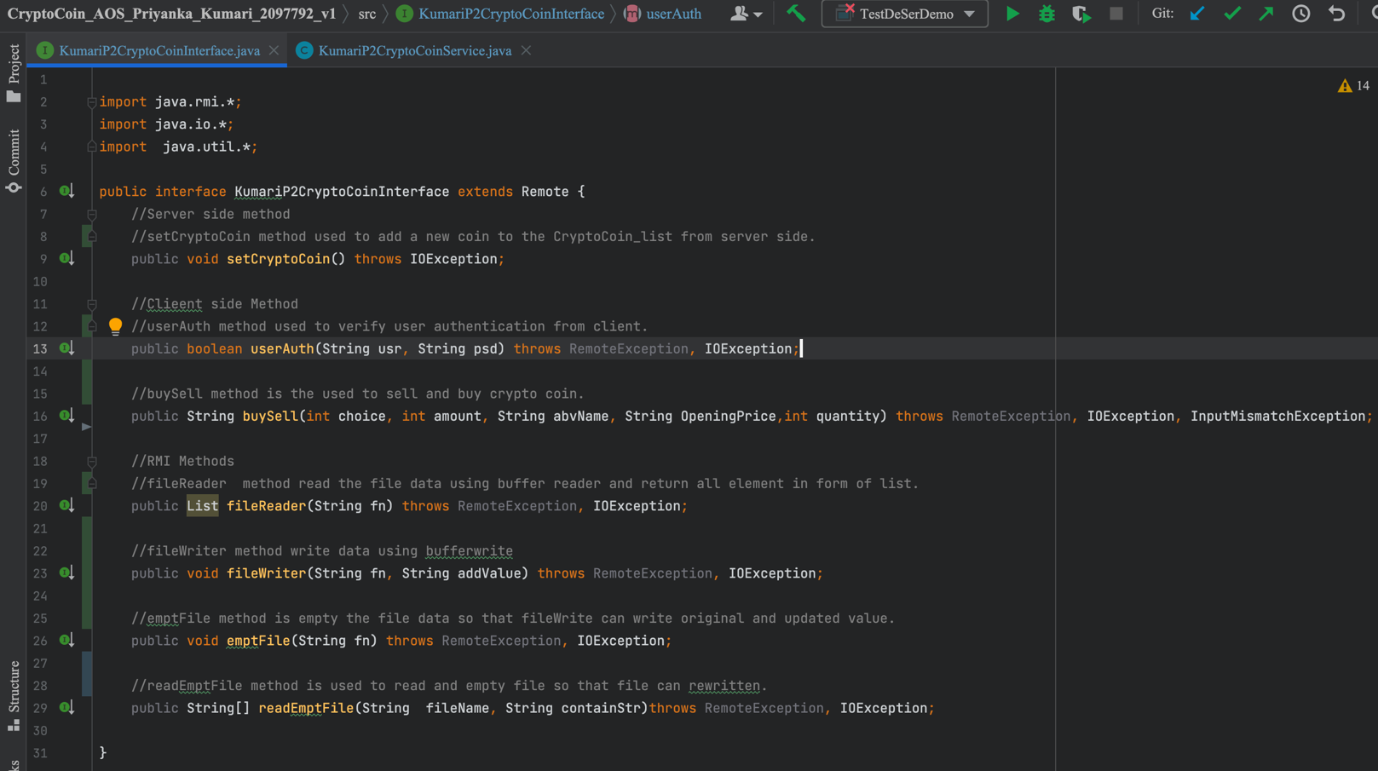

B. Interface Implement: KumariP2CryptoCoinService.java implemented the

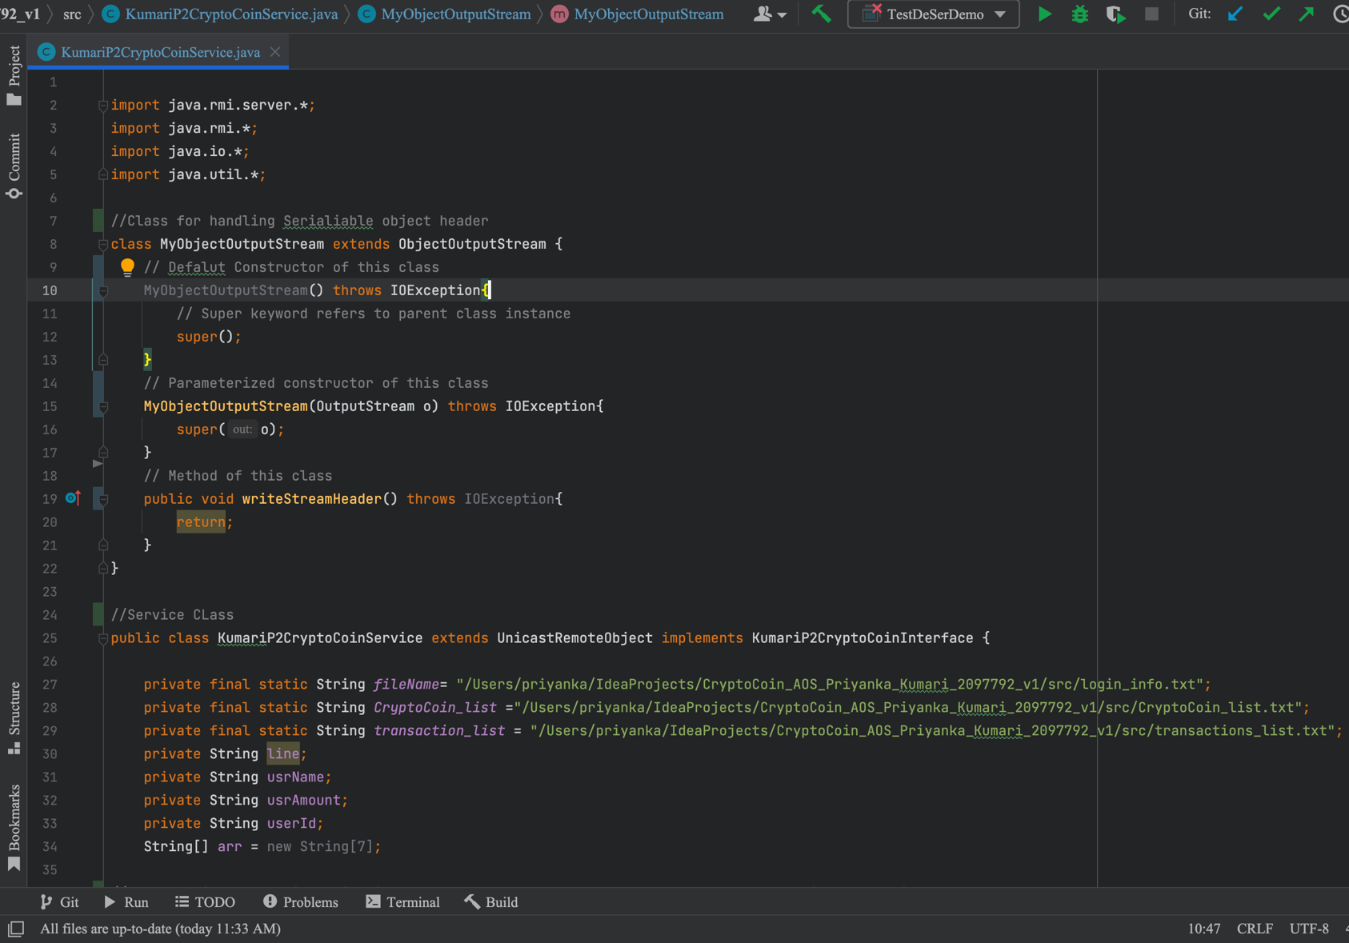  
  
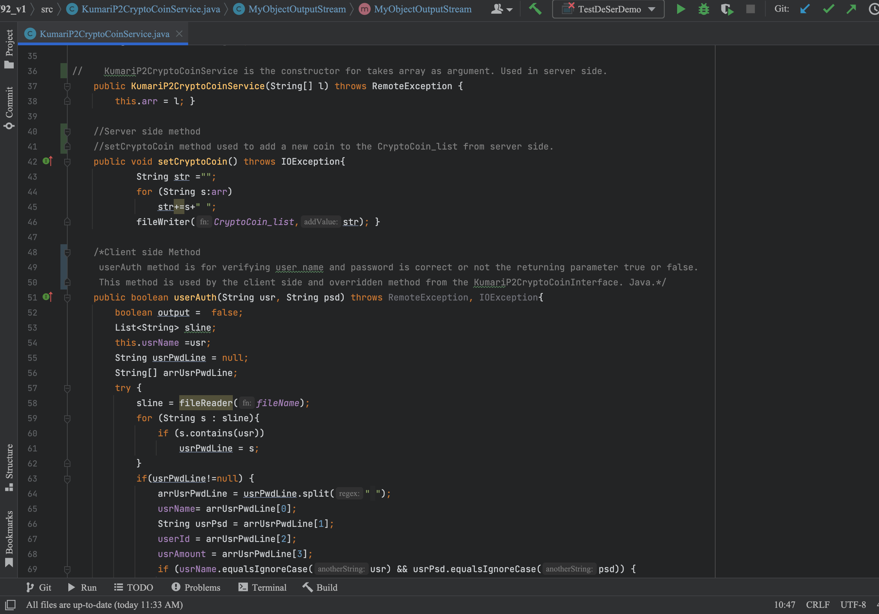  
  
  
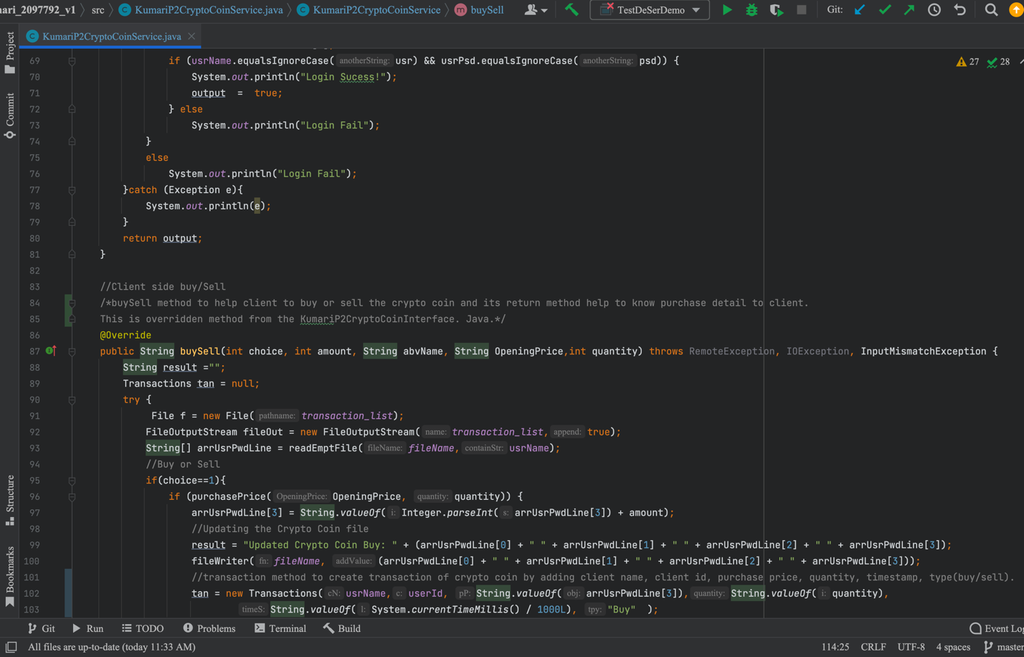  
  
  
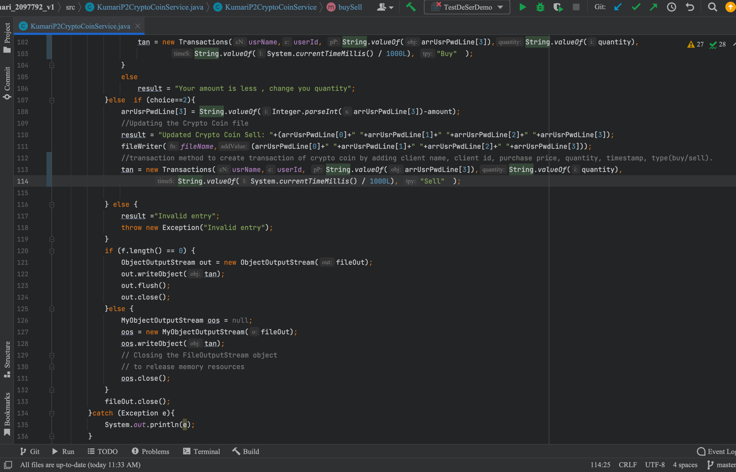  
  
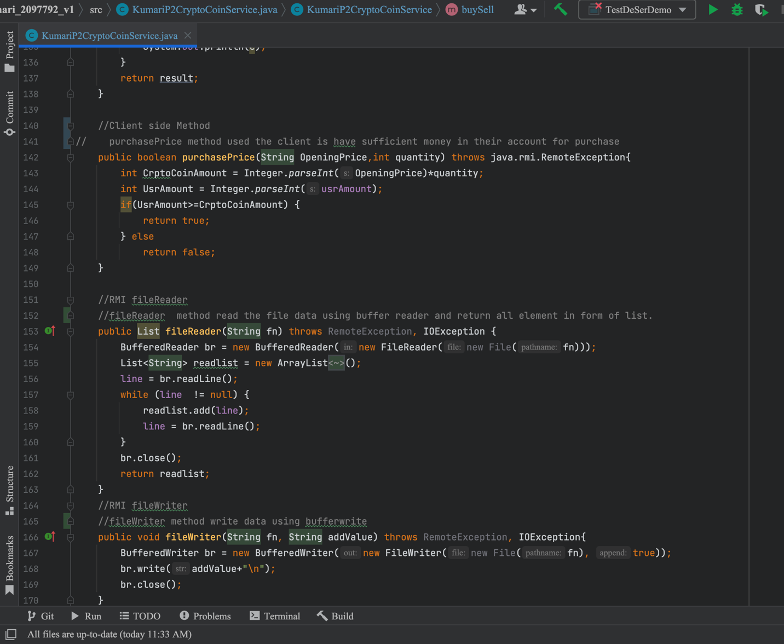  
  
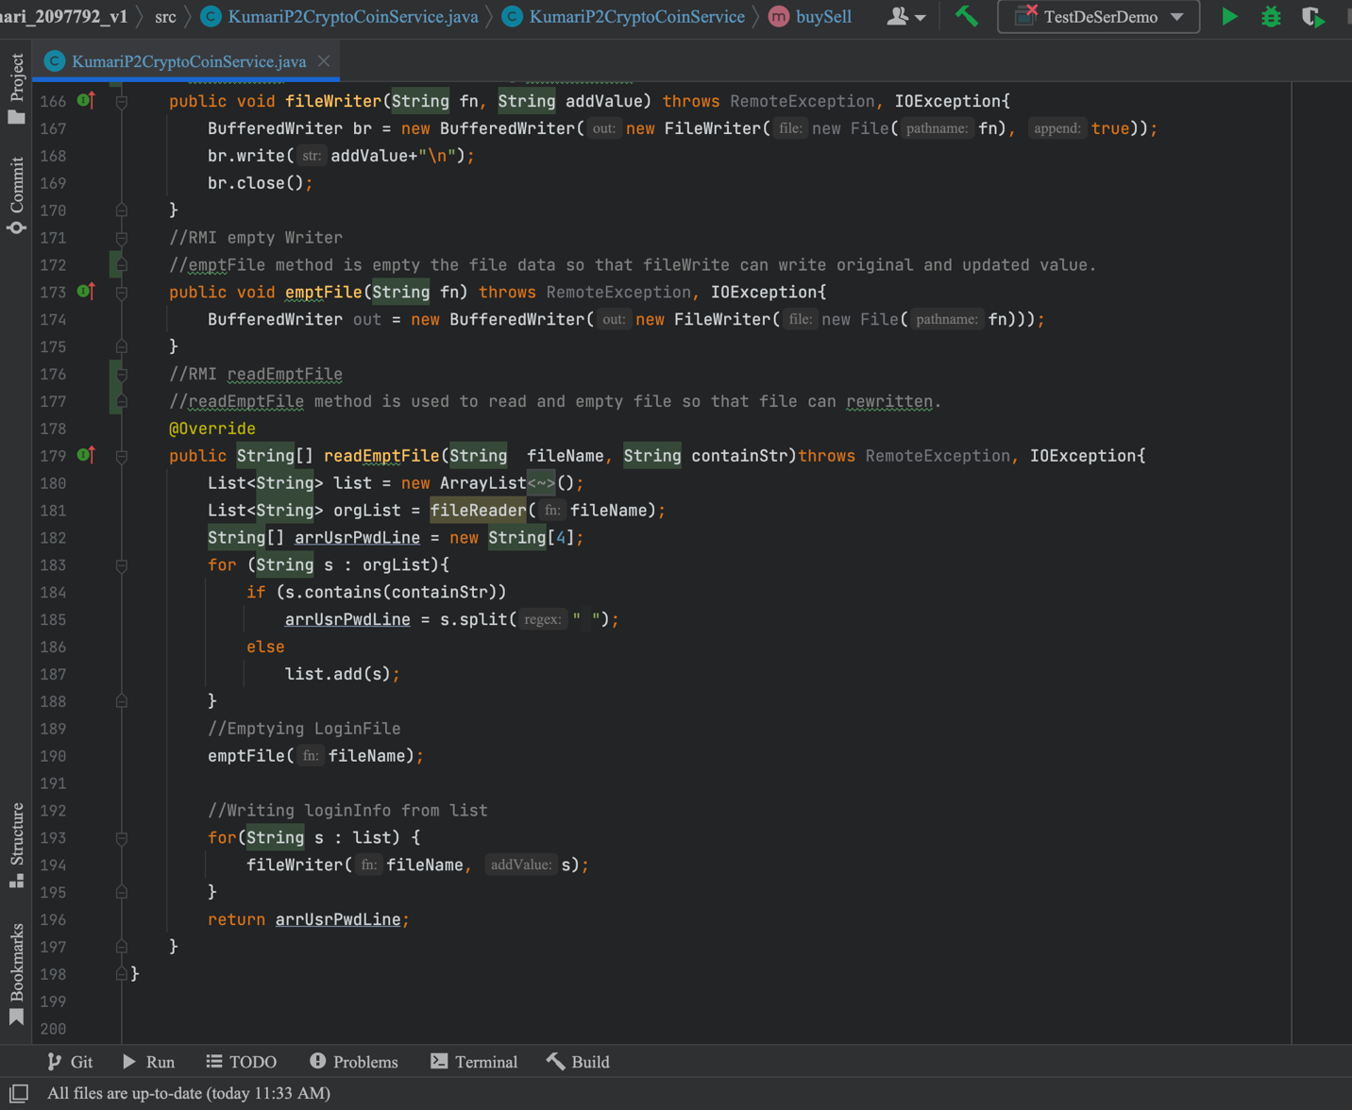

C. Server: KumariP2CryptoCoinServer.java

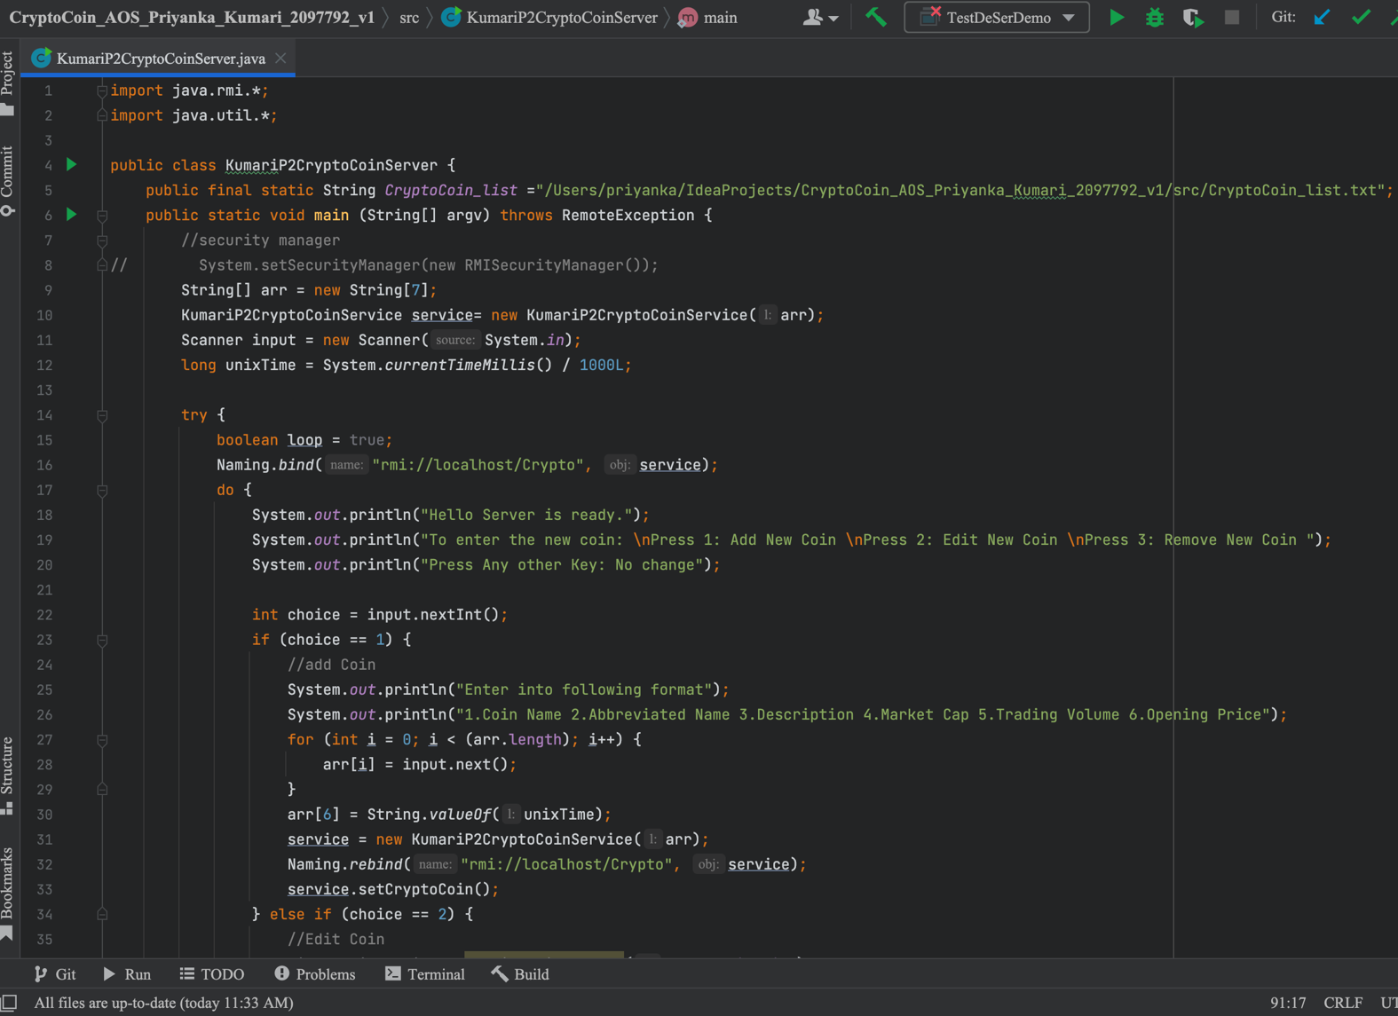  
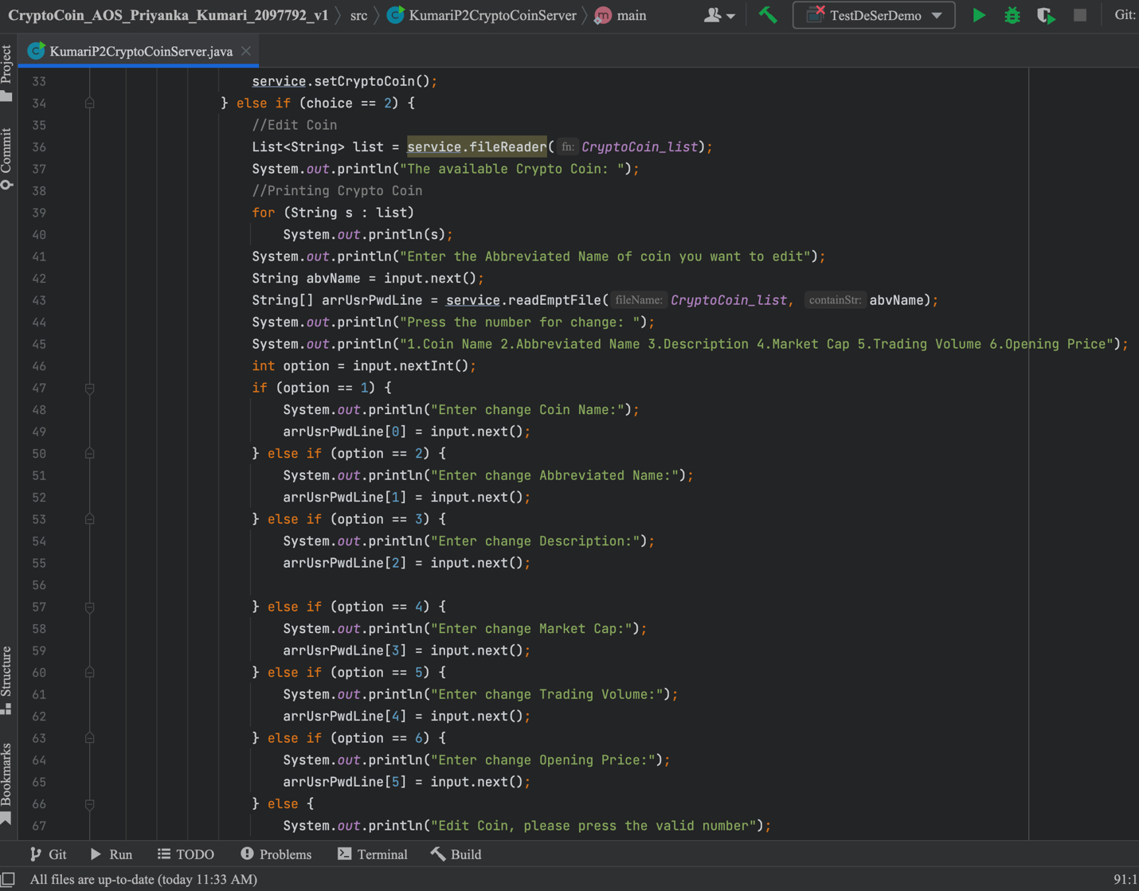  
  
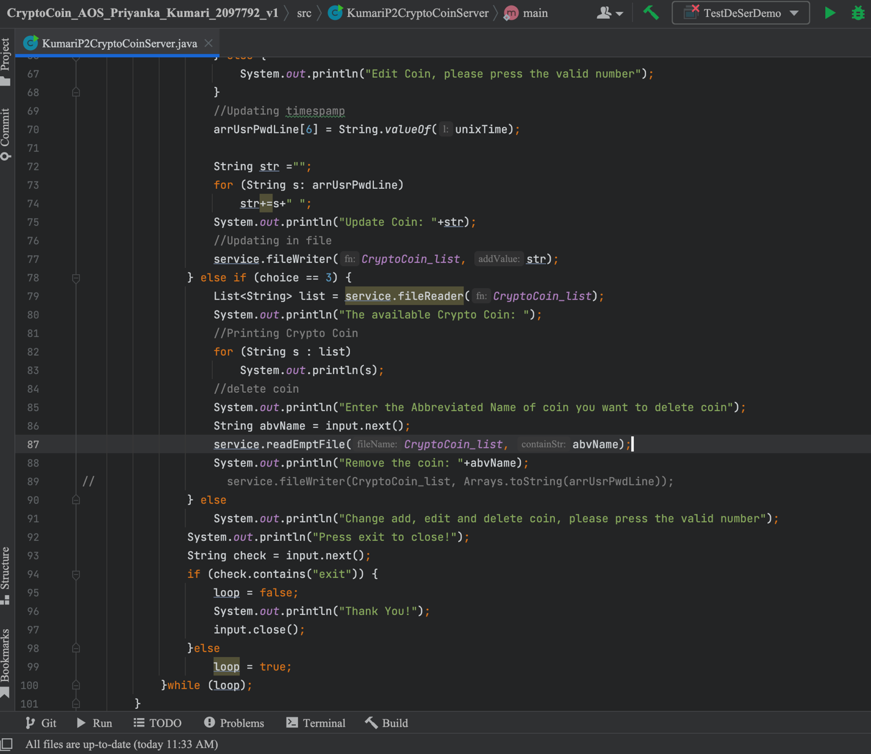  
  
  
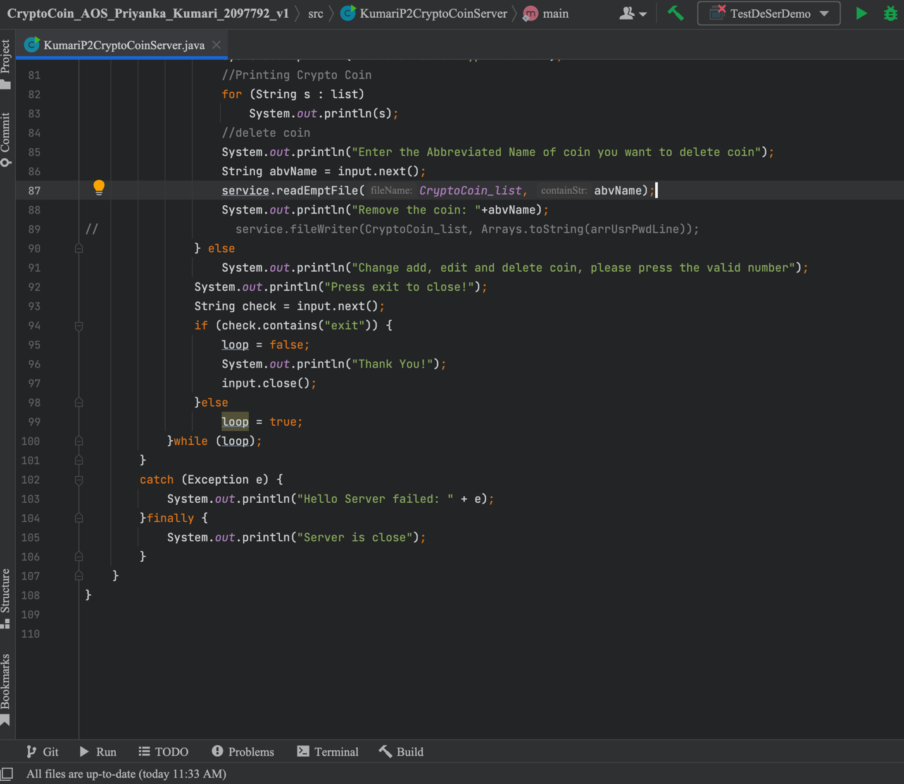

1. Client: KumariP2CryptoCoinClient.java

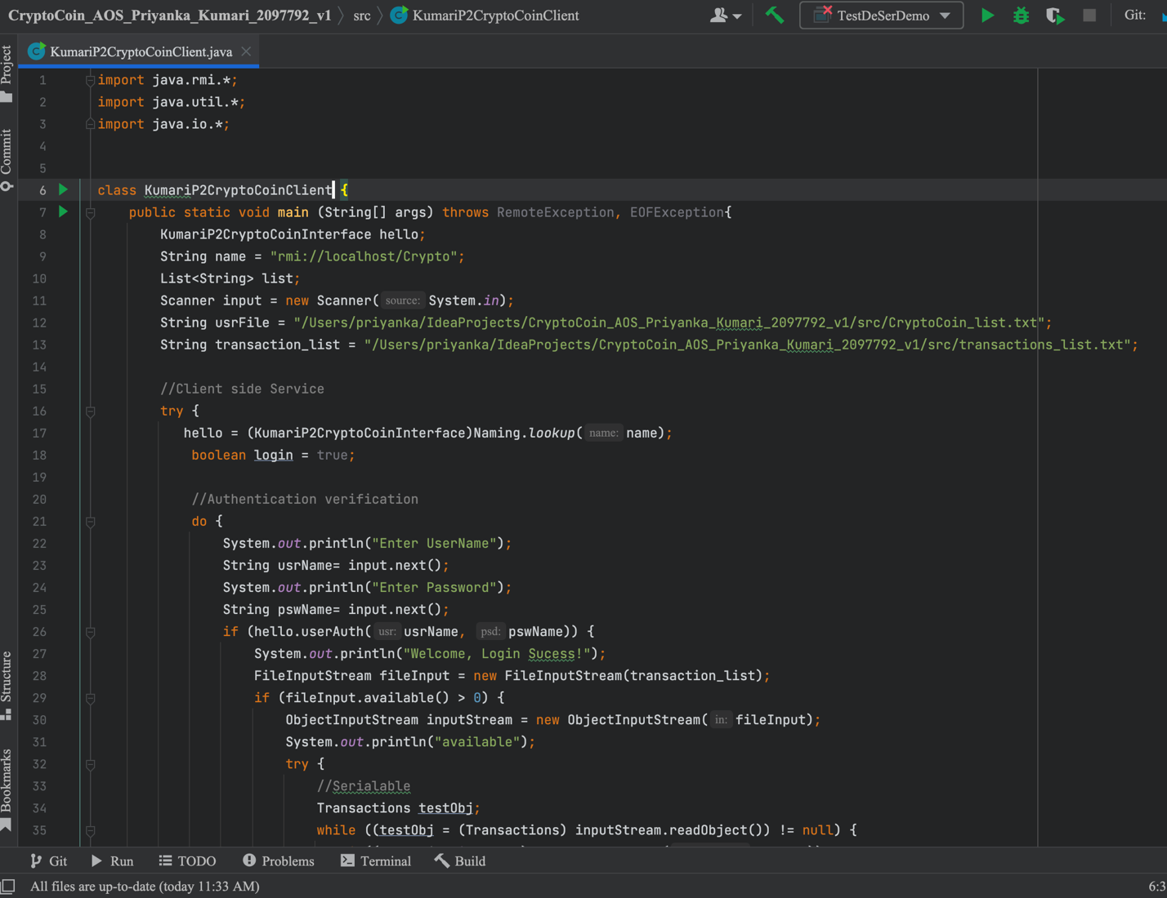  
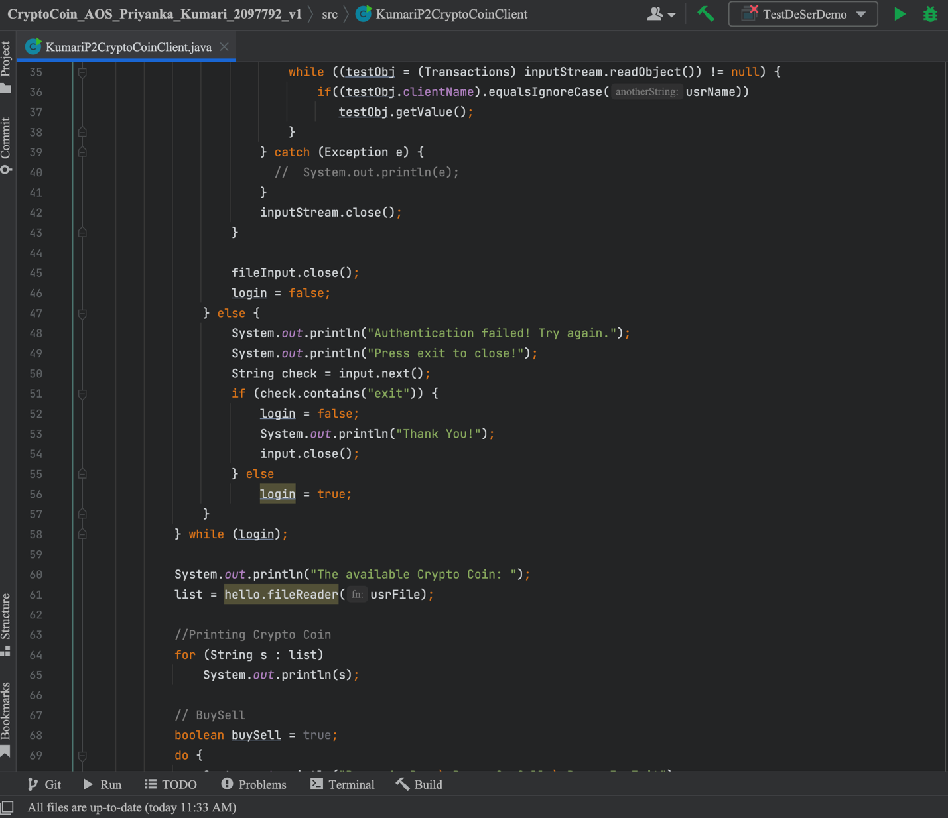  
  
  
  
  
  
  
  
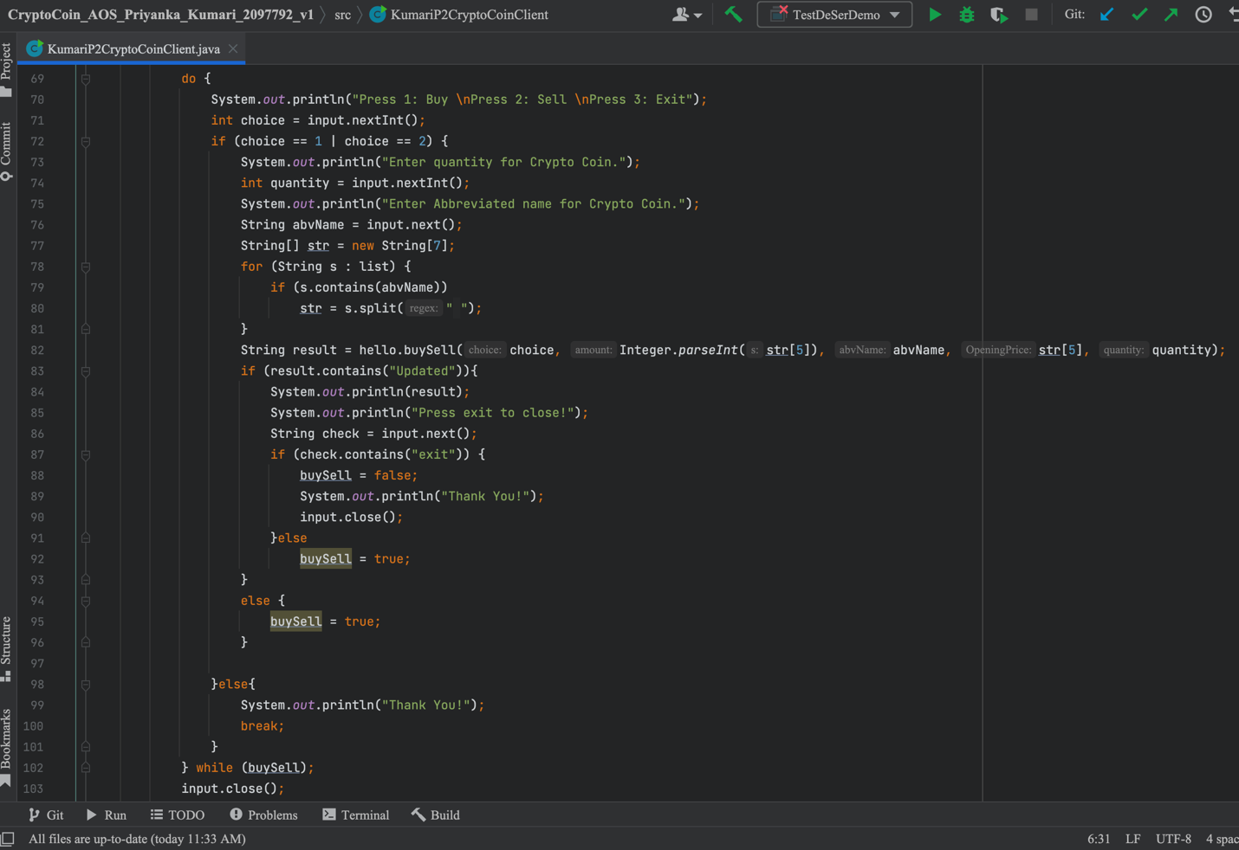  
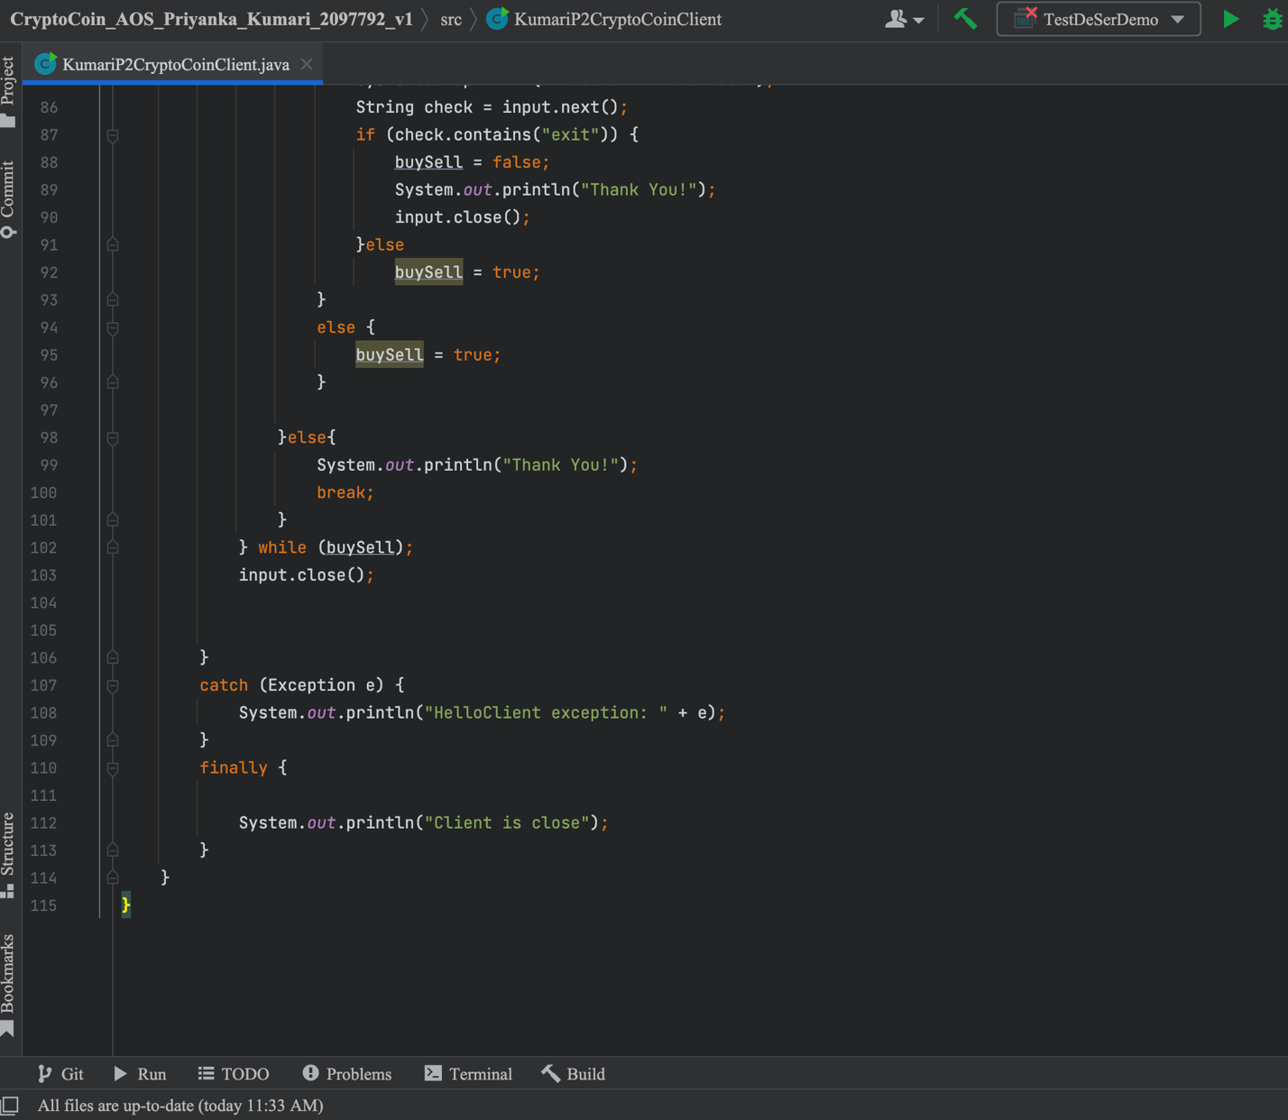  
  
 E. Serializable: Transactions.java  
  
  
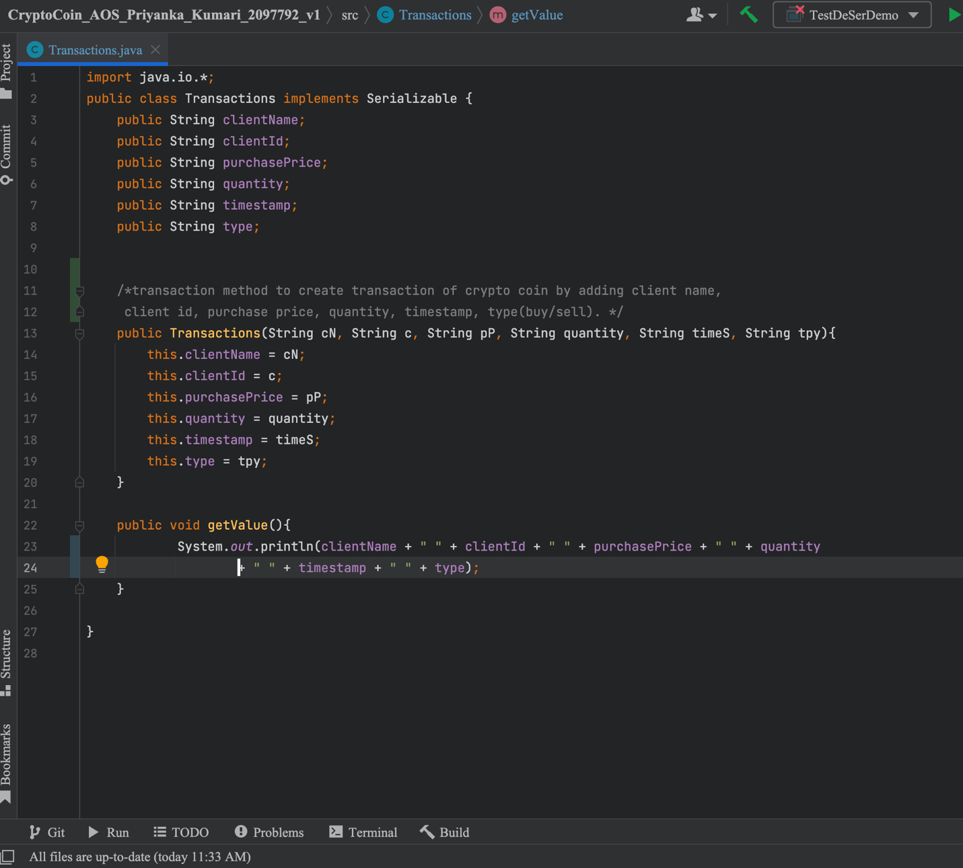

F. Others: login_info.txt, CryptoCoin_list.txt, transactions_list.txt

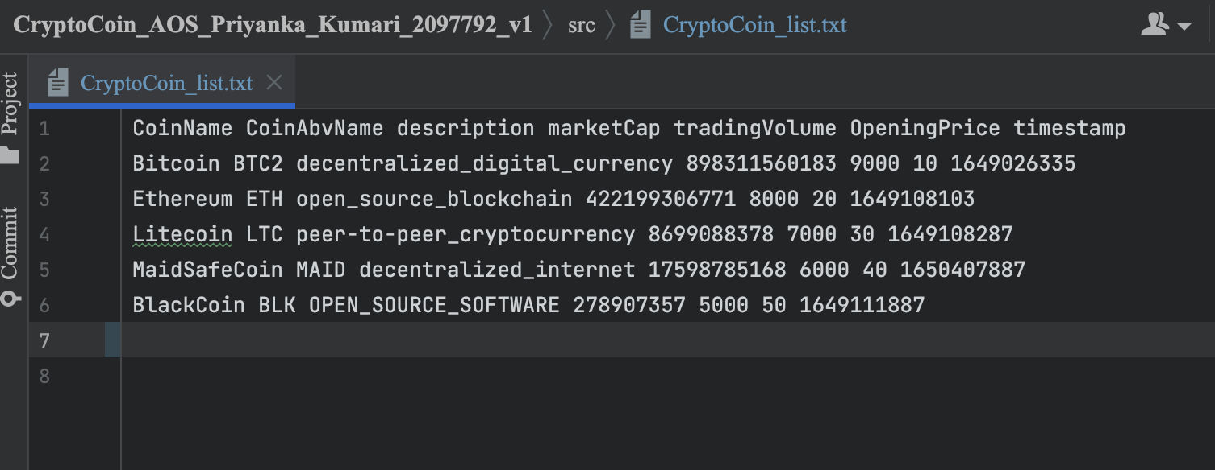  
  
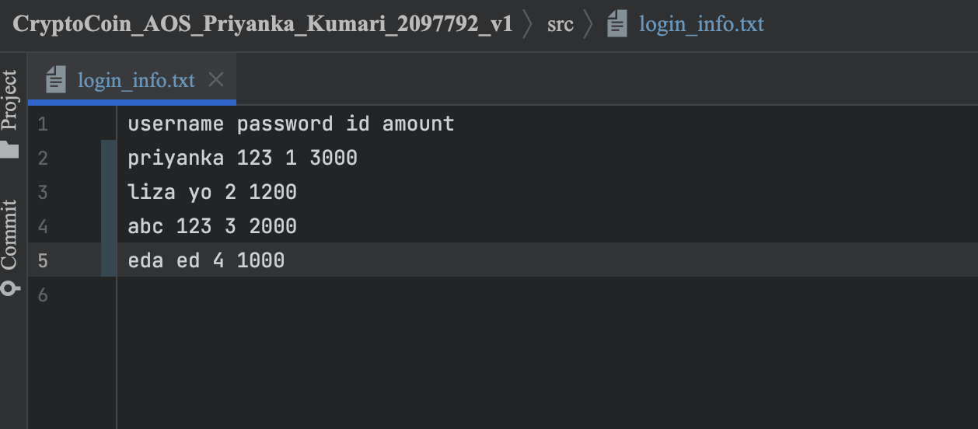  
  
  
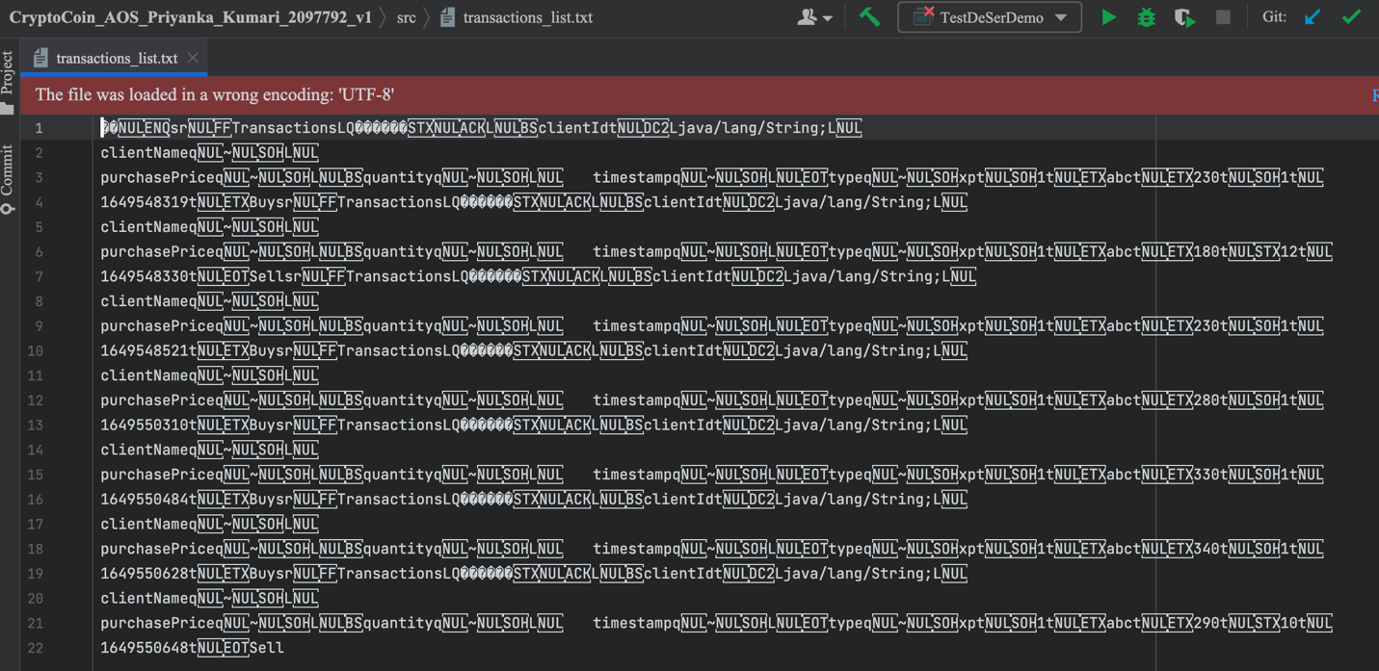

1. Result:  
     
   Client Side

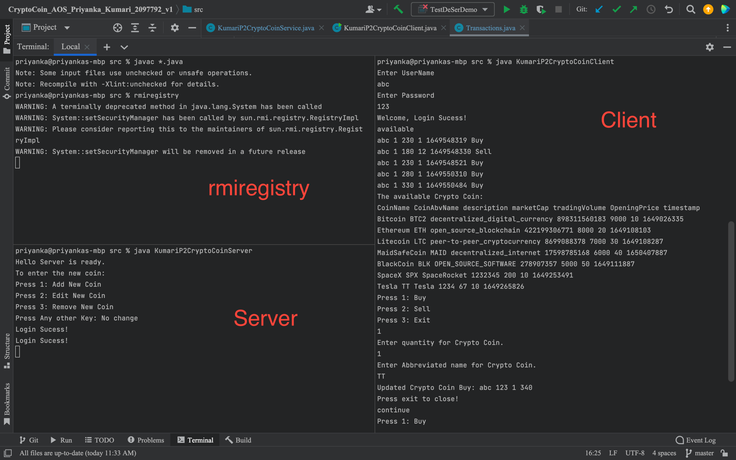

Server Adding Coin  
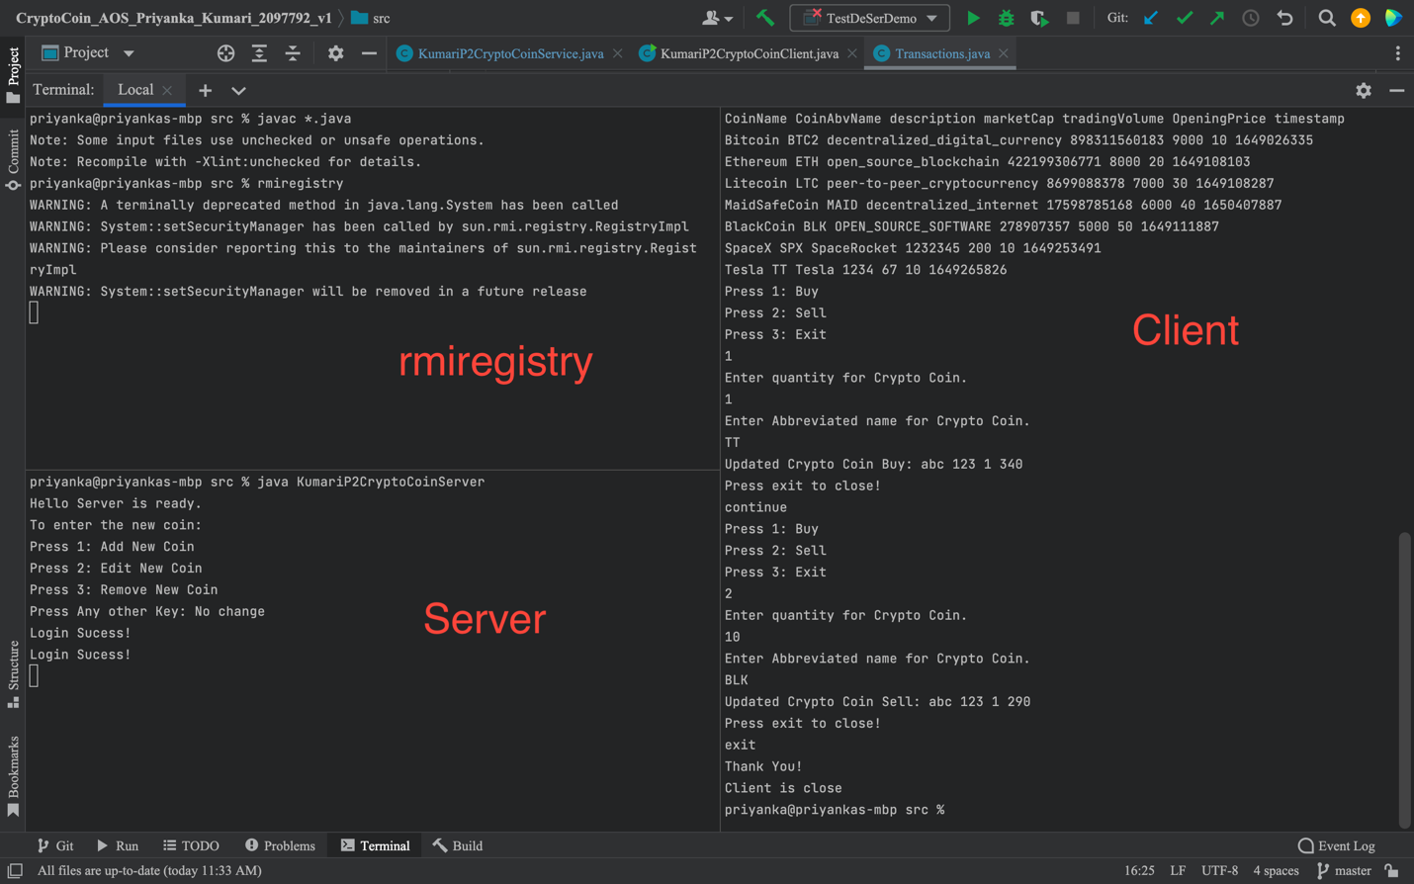  
  
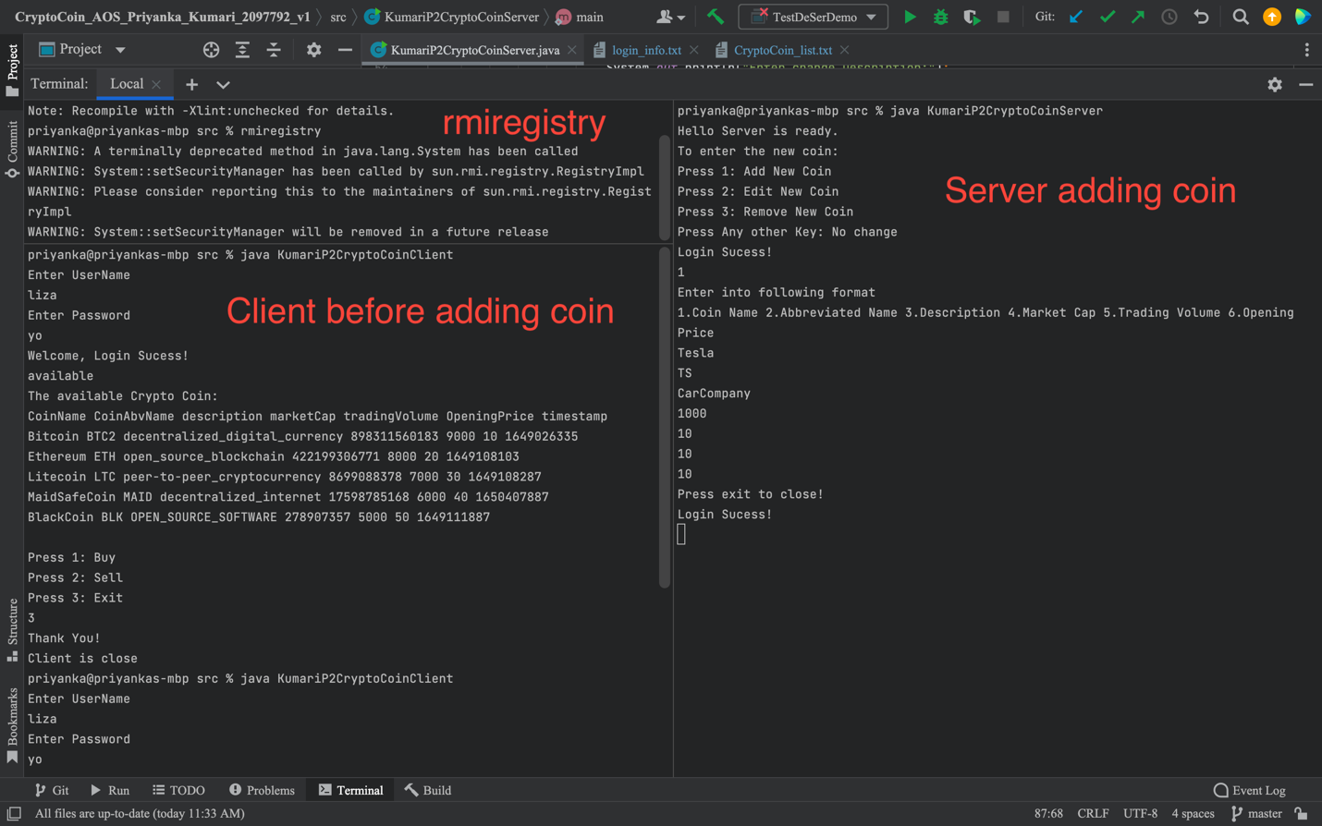

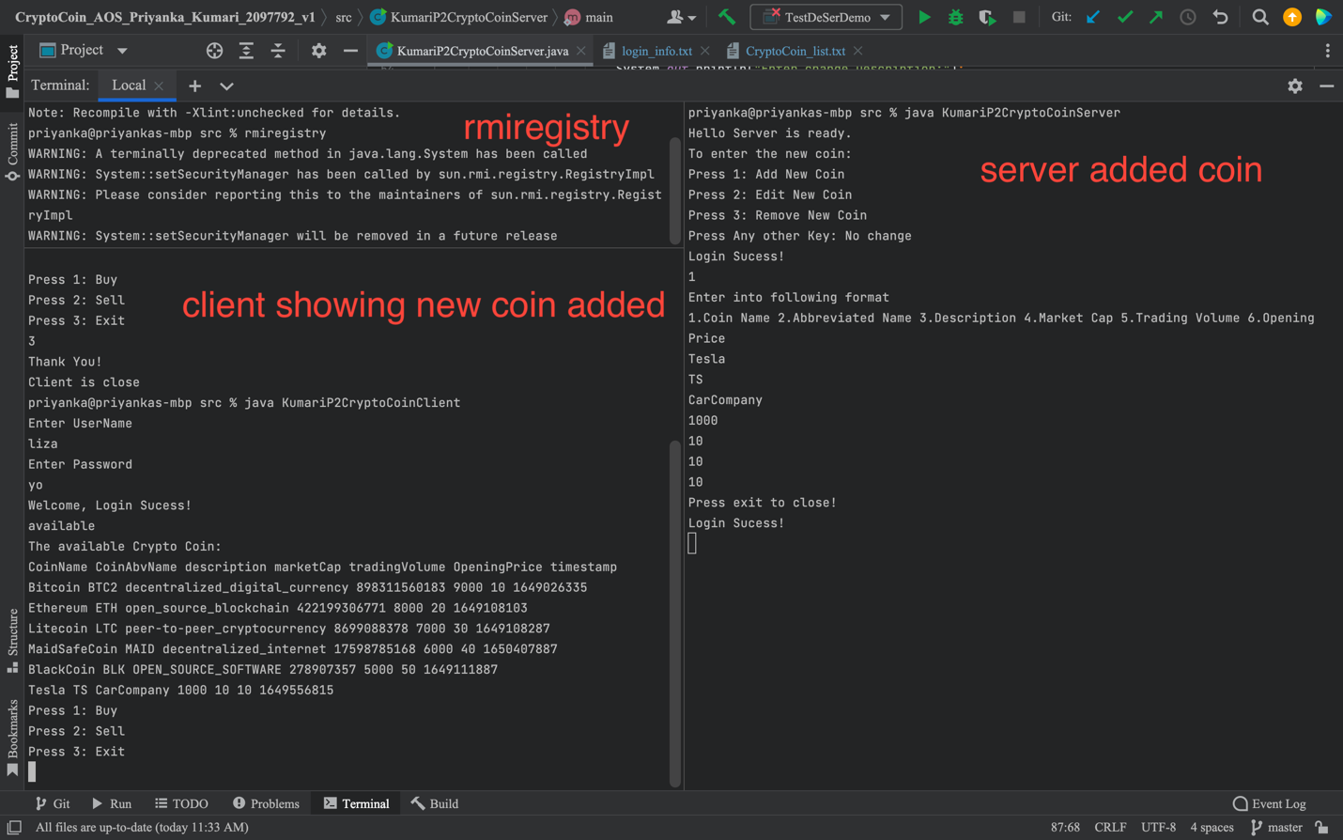 **Edit Coin**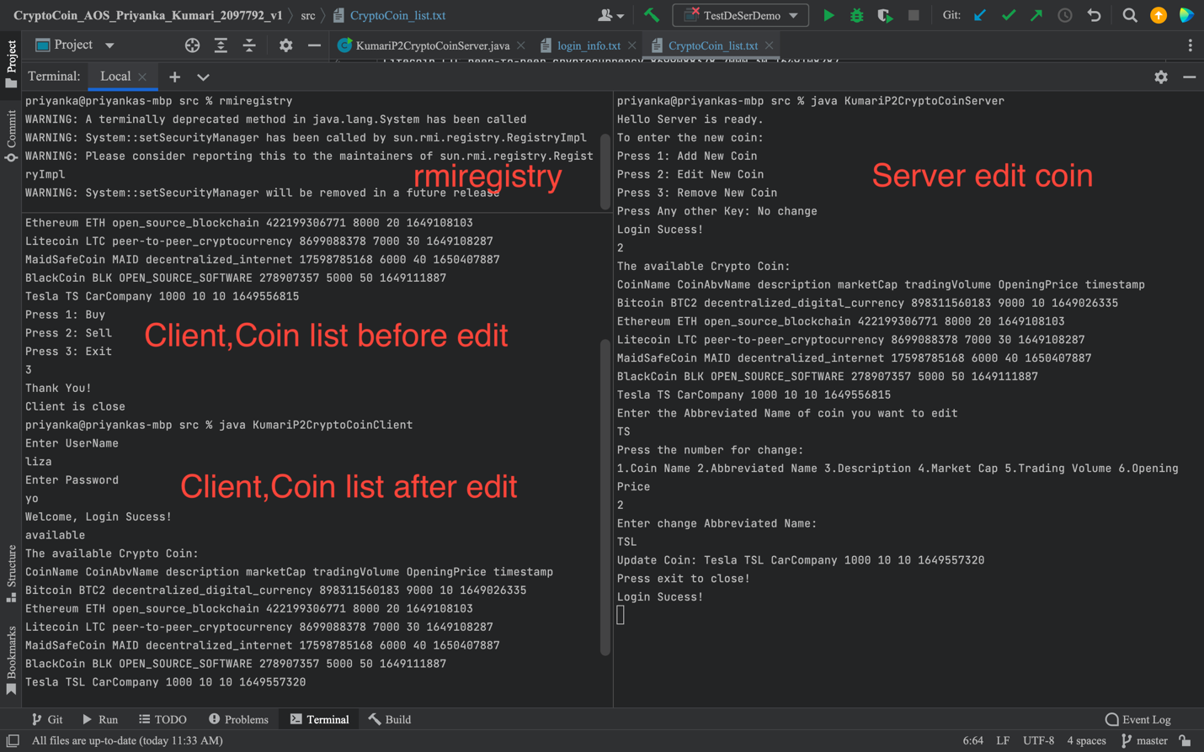

**Remove Coin**

